**Project Title**

1. Introduction

1.1. Overview: Uber is a multinational transportation network company that operates a ride-hailing platform Daily, Weekly, or Monthly Analysis: Uber data can be analysed on a daily, weekly, monthly basis to understand the trends and patterns of trip volumes. This analysis can help identify peak hours or days of high demand and optimize driver availability during those times.

1.2. Purpose: The Major of our project is to use data Analysing techniques to find unknown patterns in the Uber Drives dataset. The research is carried out on Uber drives data collected from the year 2016.

2. Problem Statement & Design thinking

2.1. Empathy Map:

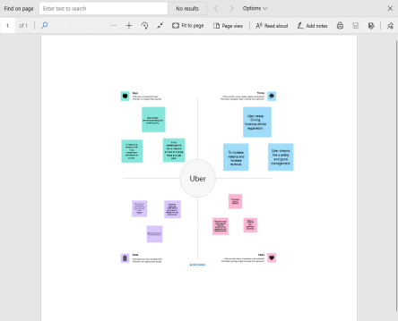

2.2. Ideation and Brainstorming Map:

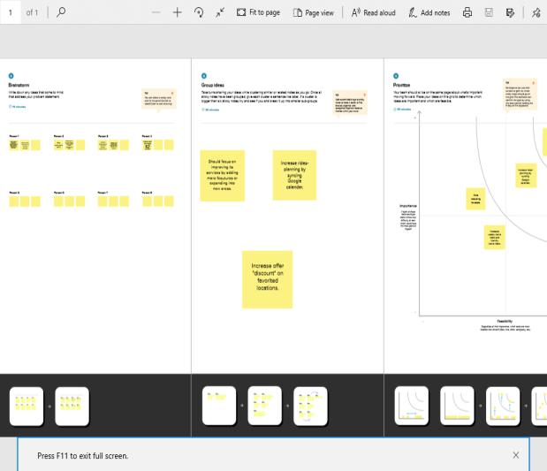

3. Result

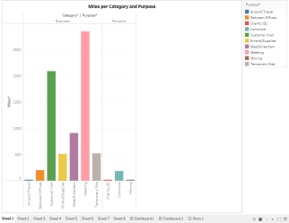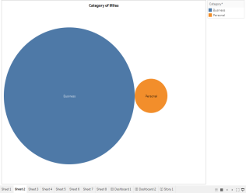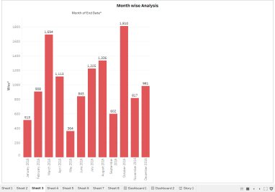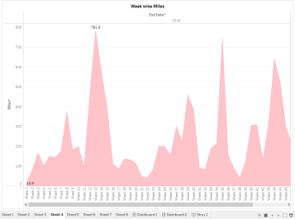

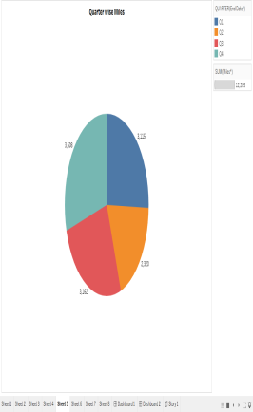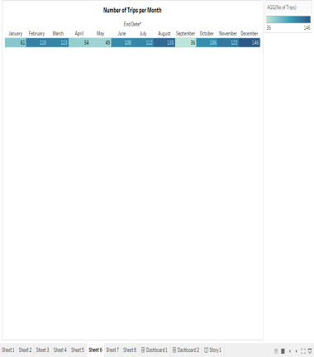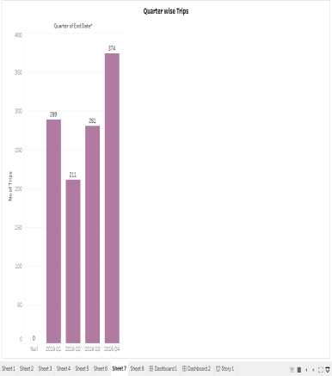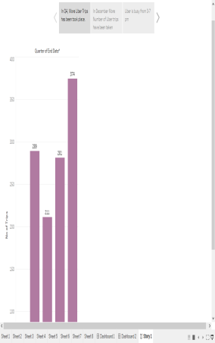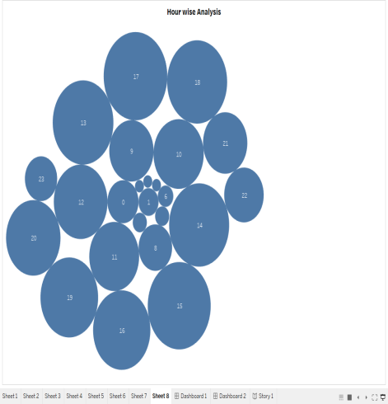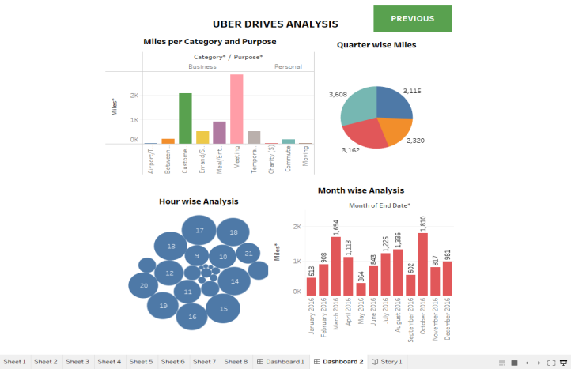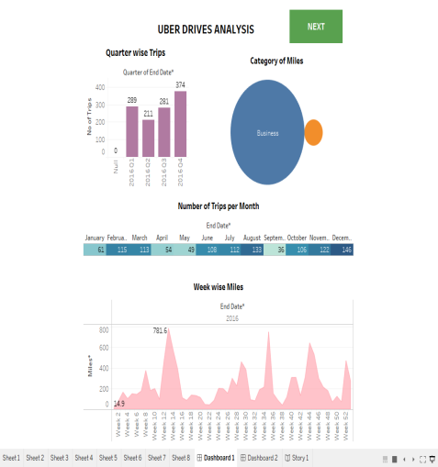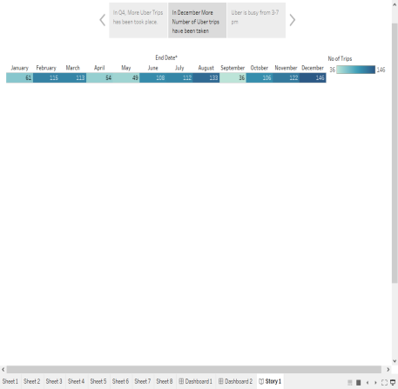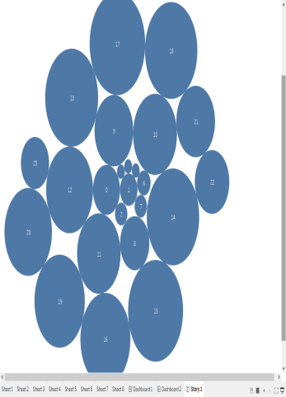

4. Advantages: This project will identify the student talent and provide them with training that will ultimately aid them in obtaining a better career.

5. Applications: The Major of our project is to use data Analysing techniques to find unknown patterns in the Uber Drives dataset. The research is carried out on Uber drives data collected from the year 2016.